Dr. Amr Hani Elsafty

**ACCREDITATION TRANSCRIPT#: BACME-ESN-040924-HLHN-16.30H**

**Has Completed the Educational Activity Titled**

**1st ENDO SHAMS First Ain Shams Endocrinology And Diabetes Annual Congress**

Which was held From 4 September 2024 to 5 September 2024 , Helnan Landmark Hotel New Cairo.

This Activity was Accredited for 16.30 Hours of the Category 1 Credit of the BACME Designation.

This Delegate Attained 16.30 Hours of the Category 1 Credit of the BACME Designation.

**Issued on**

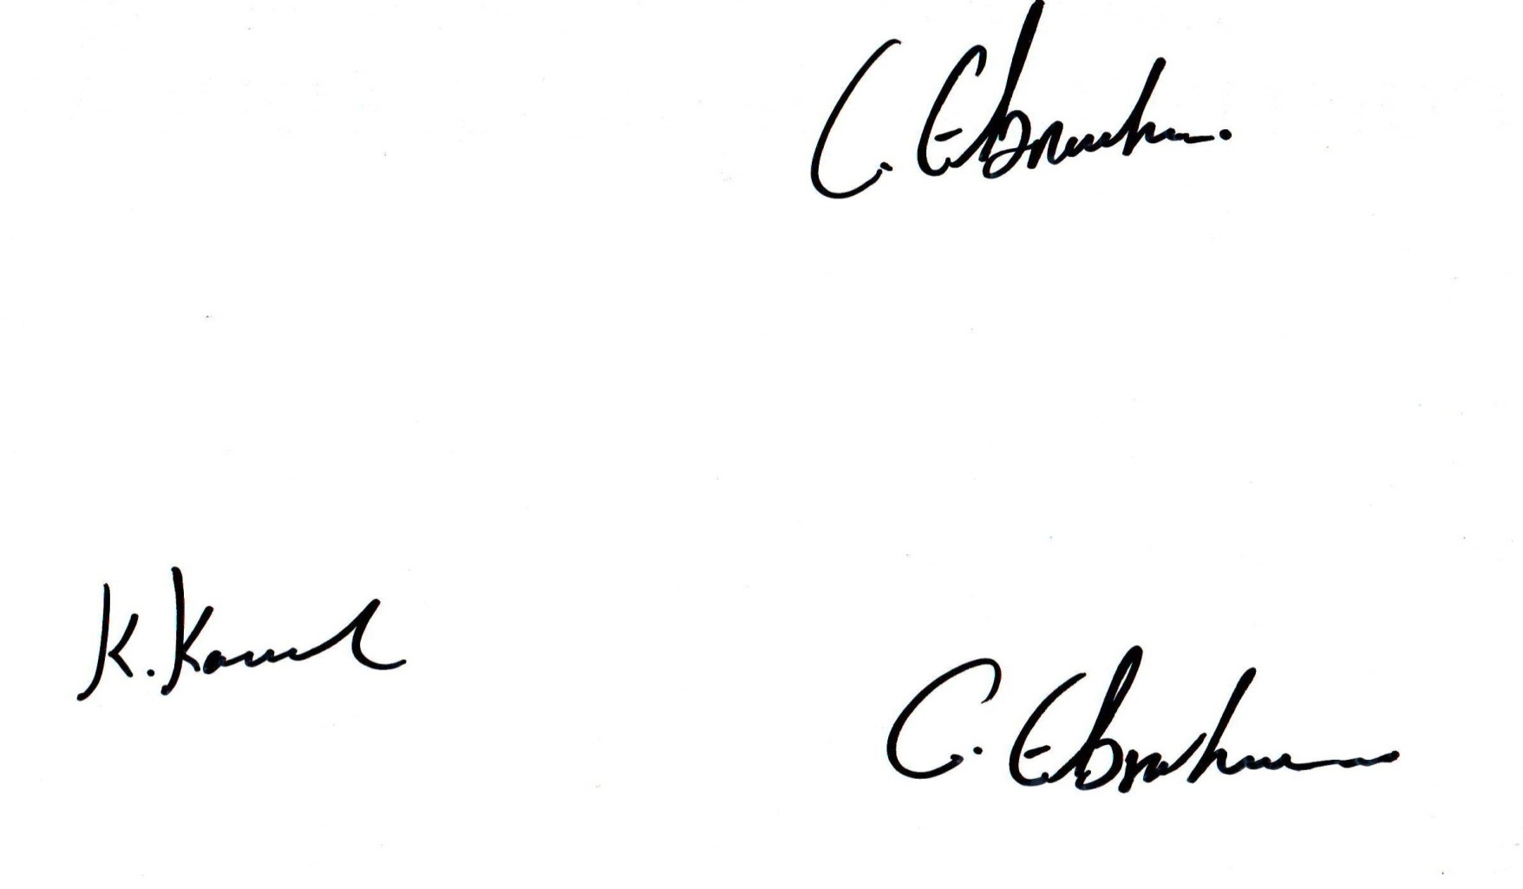 **September, 2024**

Chair, Accreditation Review Committee

Chair, Committee for Review & Recognition