**Dr. Abdul Rahman El Kinge**

**ACCREDITATION TRANSCRIPT#: BACME-AROP-280924-JMD-3H**

**WAS AN Advisor IN the scientific Activity Titled**

**A Revolutionary IcI In The Oncology Practice**

Which was held In 28 September 2024 , JW Marriott , Dubai.

This Activity was Accredited for 3 Hours of the Category 1 Credit of the BACME Designation.

This Delegate Attained 3 Hours of the Category 1 Credit of the BACME Designation.

**Issued on**

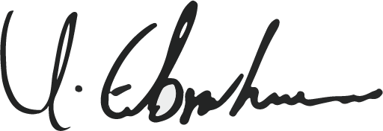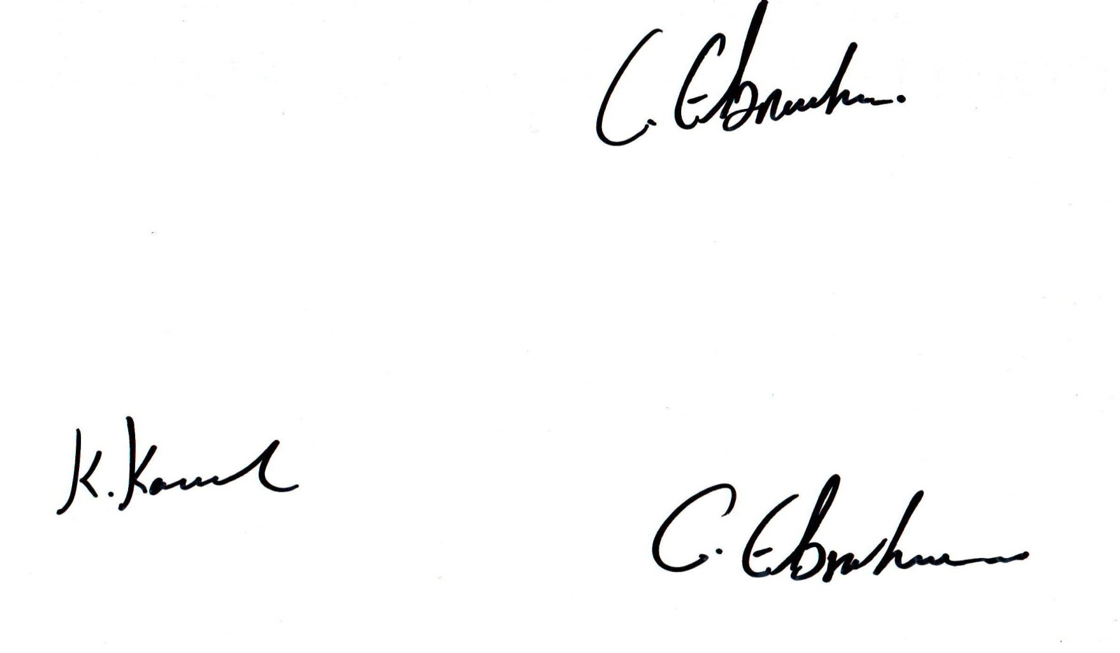 **September, 2024**

Chair, Accreditation Review Committee

Chair, Committee for Review & Recognition